L0-D2 — K–M Model Specification
Version: 0.2 (Draft) Status: In Progress Last Updated: 05 June 2026

1. Purpose
The K–M Model Specification defines the dual-axis civilisational maturity model that underpins CivOS. It establishes:
- the K-axis (technological/energetic capacity)
- the M-axis (psychosocial/institutional maturity)
- the mathematical formulation of both
- the K–M mismatch as a structural risk indicator
- the implications for architecture, governance, and constraints
This deliverable ensures CivOS is grounded in a structured, falsifiable, non-ideological framework for understanding civilisational stability.

2. Scope
Included:
- Definitions of the K and M axes
- Mathematical expressions
- Thresholds and interpretation
- The Δ mismatch concept
- Epistemic limits and assumptions
- Implications for CivOS architecture
- Diagram references
Not included:
- Governance mechanisms (L0-D5)
- Architecture structure (L0-D1)
- Risk register detail (L0-D6)
- Implementation standards (L1)
- Operational processes (L2–L5)

3. Definitions & Concepts

3.1 Kardashev Scale (K-axis)
A logarithmic measure of a civilisation’s ability to harness and control energy.

3.2 Maslow-Derived Maturity Scale (M-axis)
A composite measure of psychosocial, institutional, and organisational maturity, based on:
- stability
- trust
- cooperation
- governance quality
- conflict resolution
- long-term planning
- shared reality
- psychosocial resilience

3.3 K–M Mismatch
The gap between a civilisation’s power (K) and its maturity (M). Large mismatches increase systemic risk.

3.4 Great Filter Interpretation
Civilisations fail when K rises faster than M. CivOS exists to raise M to keep pace with the increase in K.

3.5 Model Status and Epistemic Limits
The K–M model is a structured heuristic, not an empirically validated law. It is designed to:
- make civilisational risk legible
- provide a consistent conceptual framework
- support architectural reasoning
However:
- no civilisation has recorded K and M values across collapse events
- M cannot be directly measured as a single scalar
- Δ thresholds are provisional
- the model is subject to revision
This ensures the model is used appropriately and not over-interpreted.

4. Core Specification

4.1 Mathematical Definition of the K-Axis
$$K=\frac{{log⁡}_{10}(E)-6}{10}$$
Where:
- $E$= energy harnessed (in watts)
- 10⁶ W = baseline for K = 0
- 10¹⁶ W = planetary scale (K ≈ 1)
- 10²⁶ W = stellar scale (K ≈ 2)
Humanity’s current value:
$$K≈0.73$$

4.2 Mathematical Definition of the M-Axis
The M axis represents civilisational psychosocial maturity expressed as a normalised value in the interval $\left[0 , 1\right]$. It is constructed as a composite index derived from eight maturity dimensions, each scored on a standardised scale.
Let:
$$m_{i}∈[0,1]\text{for }i=1,…,8$$
The normalised maturity score for each dimension:
- Physiological Security & Basic Needs Reliability
- Safety, Stability & Rule-of-Law Integrity
- Social Cohesion & Trust Architecture
- Epistemic Health & Information Integrity
- Governance Capability & Institutional Competence
- Technological Alignment & Risk Stewardship
- Economic Resilience & Resource Stewardship
- Flourishing, Agency & Human Development
The overall maturity index M is defined as the arithmetic mean:
$$M=\frac{1}{8}\sum_{i=1}^{8}{m_{i}}$$
Each $m_{i}$is assessed using a qualitative rubric mapped onto $\left[0 , 1\right]$, reflecting the degree to which the civilisation demonstrates capability, reliability, foresight, and resilience in that domain.
Because the underlying dimensions are qualitative and judgement-based, the resulting value of M should be interpreted as a conceptual approximation, suitable for directional analysis and stability modelling, rather than as a precise empirical measurement.

4.3 The K–M Mismatch
$$Δ=K-M$$
Δ is a directional indicator, not a precise measurement. It should be interpreted as:
- a relative comparison
- a risk signal
- a heuristic guide for architectural decisions
Humanity’s current mismatch:
$$Δ≈0.23$$
This places humanity in the indicative risk region, not a mathematically proven one.

4.4 Implications for CivOS
CivOS exists to:
- raise M as well as K
- stabilise Δ (the mismatch)
- ensure governance scales with capability
- reduce systemic fragility
This justifies CivOS principles such as:
- governance clarity
- anti-capture
- shared reality
- observability
- constraint-first design
- modularity
- replaceability

4.5 Thresholds and Interpretation
Region | Δ Value | Interpretation
Stable | Δ ≤ 0.1 | Indicative alignment between capability and maturity
Tension | 0.1 < Δ ≤ 0.2 | Early signs of strain; requires monitoring
Risk Zone | 0.2 < Δ ≤ 0.4 | Maturity may be insufficient; intervention advisable
Unstable | 0.4 < Δ ≤ 0.6 | High likelihood of systemic stress
Critical | Δ > 0.6 | Severe imbalance; collapse risk elevated
These thresholds are provisional and based on:
- historical analogies
- expert judgement
- theoretical reasoning
They are not empirically calibrated.

4.6 Diagram Reference

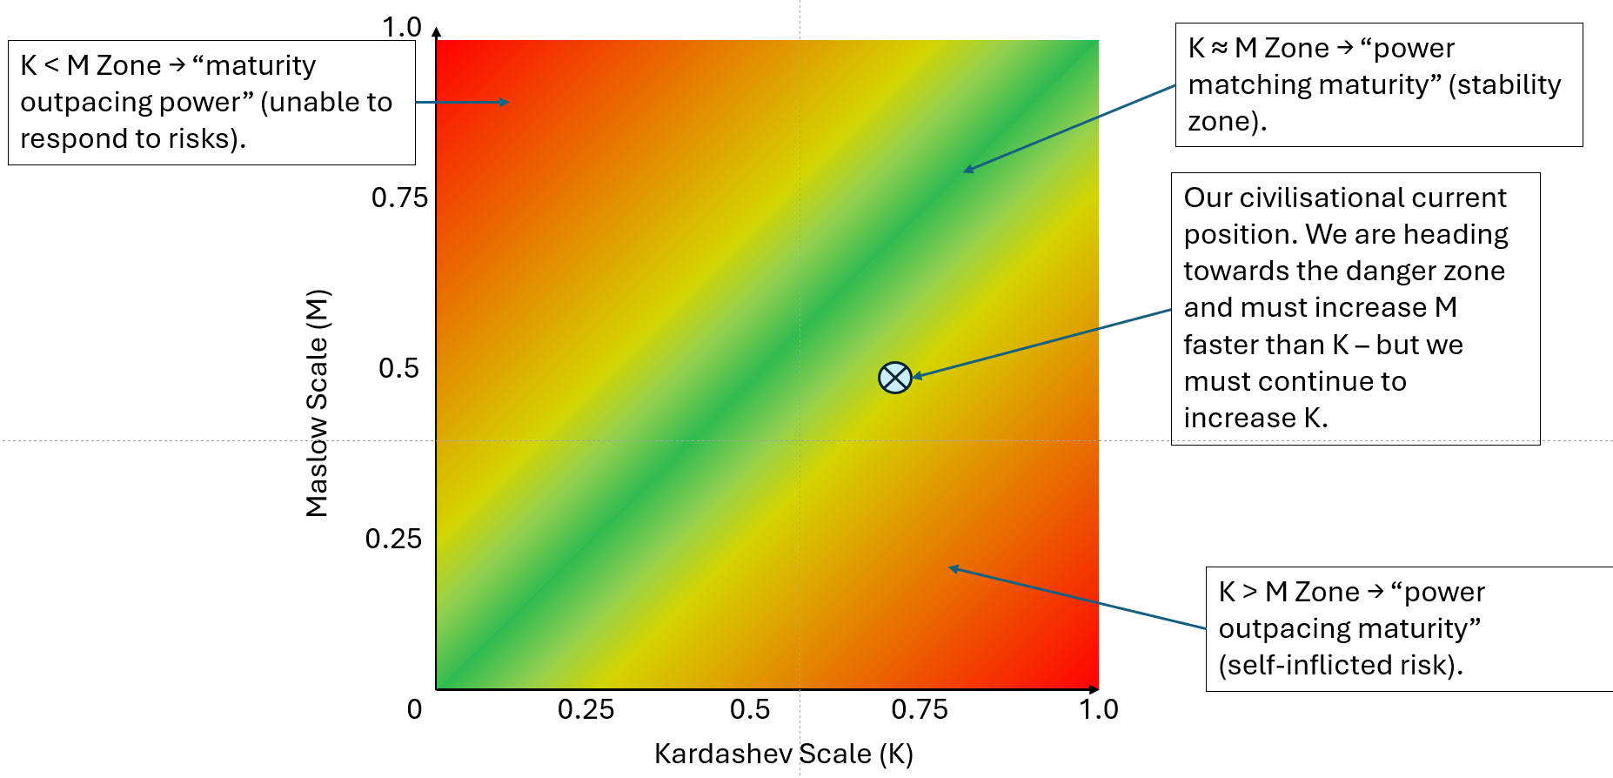

Stored in: GitHub CivOS repository
Includes:
- K axis
- M axis
- Δ mismatch
- Stability regions
- Humanity’s approximate position

5. Dependencies
This deliverable depends on:
- BOSCARD
- L0-D1 — Architecture Blueprint
- L0-D3 — Scope & Boundaries
- L0-D7 — Assumptions & Dependencies

6. Interfaces
Upstream of:
- L0-D4 — Anti-Capture Doctrine
- L0-D5 — Governance Principles
- L0-D6 — Risk Register
- L0-D8 — Success Criteria
- L0-D9 — L1 Roadmap
- All L1 standards
- All L2 Families

7. Risks & Constraints
- Model may be misinterpreted as predictive
- Numerical values may imply false precision
- Thresholds may be culturally biased
- M-axis oversimplifies complex sociopolitical dynamics
- Δ may behave non-linearly
- Lack of empirical calibration limits confidence
- Potential political misuse

8. Success Criteria
- K and M axes are clearly defined
- Mathematical expressions are unambiguous
- Δ mismatch is interpretable
- Thresholds are justified as provisional
- Epistemic limits are explicit
- Model supports architectural reasoning
- Diagram matches the written model

9. Version History
Version | Date | Author | Notes
0.1 | 05-06-2026 | Steve | Initial draft
0.2 | 05-06-2026 | Steve | Added epistemic limits, revised thresholds, clarified model status

10. Future Work and Validation Path
To improve rigour:
- Analyse historical civilisational stress events
- Develop measurable indicators for each M-dimension
- Perform cross-cultural calibration
- Explore non-linear Δ behaviour
- Conduct simulation studies
- Integrate ecological and technological forecasting
This ensures the model evolves with evidence.

